TASK 1 - ONLINE SURVEY SYSTEM

NAME – SANSKAR SACHIN GULAVE

EMAIL ID – [sanskargulave05@gmail.com](mailto:sanskargulave05@gmail.com)

BATCH – B16 INTERNCROWD

Introduction

* Online Survey System Project is developed in Java programming language to facilitate online survey.
* The main aim of the project is to form a platform to collect the viewpoints of related people about a particular survey topic.
* It can also be implemented in any organizations or college for carrying out survey of any kind.
* This project helps in lots of fields for taking surveys about a topics what people thinking about or if they have an issues they can express through the surveys.

Objective

* Online Survey System is easy and comfortable to use.
* In this application, the answers of the participants are collected and organise in a database.
* The system is designed in such a way that it automatically adds the votes to each alternative and after the deadline of survey it displays the result.
* All the activities in the project are controlled by admin of the survey.
* The implementation of project avoids the programs such as meetings, conferences etc. to take any decision or research.
* With the help of this online system, one can easily forward his/her ideas and viewpoints to the officials.

CODE – CREATE SURVEY

package com.jdbc.surveysystem;

import java.sql.Connection;

import java.sql.DriverManager;

import java.sql.PreparedStatement;

import java.sql.SQLException;

import java.sql.Statement;

import java.util.Scanner;

public class CreateSurvey{

private static Scanner scanner = new Scanner(System.in);

static final String DB_URL = "jdbc:mysql://localhost/surveyjdbc";

static final String USER = "root";

static final String PASS = "rootp";

public static void main(String[] args) {

// Open a connection

}

public void createYourSurvey(String surveyId) throws SQLException

{

try(Connection conn = DriverManager.getConnection(DB_URL, USER, PASS);)

{

Statement stmt = conn.createStatement();

String sql = "CREATE TABLE "+surveyId+"(questionno INTEGER not NULL, " +" questions VARCHAR(255), " +

" option1 VARCHAR(100), " + " option2 VARCHAR(100), " +" option3 VARCHAR(100), " +

" option4 VARCHAR(100), " +" option5 VARCHAR(100), " +" PRIMARY KEY ( questionno ))";

stmt.executeUpdate(sql);

System.out.println(" CREATE YOUR SURVEY QUESTIONS \n");

System.out.print("How many question do you want to create : ");

int noOfQuestions = Integer.parseInt(scanner.nextLine());

for(int i=1;i<=noOfQuestions;i++)

{

String sql1 ="insert into "+surveyId.toLowerCase()+" (questionno, questions, option1, option2, option3, option4, option5) values (?,?,?,?,?,?,?)";

PreparedStatement preparedStatement = conn.prepareStatement(sql1);

preparedStatement.setInt(1,i);

System.out.print("\nEnter Question "+i+" : ");

preparedStatement.setString(2,scanner.nextLine());

System.out.print("Enter no. of Options : ");

int noOfOptions = Integer.parseInt(scanner.nextLine());

int m=0;

for(int j=1; j<= noOfOptions;j++)

{

m=j+2;

System.out.print("Enter your Option "+j+": ");

preparedStatement.setString(m,scanner.nextLine());

}

for(int k=m+1;k<=7;k++)

{

preparedStatement.setString(m+1,null);

m++;

}

preparedStatement.executeUpdate();

}

System.out.println("\n Your Survey is Created \n");

System.out.println("______________________________________________________________________________________________\n");

} catch (SQLException e) {

e.printStackTrace();

}

}

}

CODE 2 – TAKE SURVEY

package com.jdbc.surveysystem;

import java.sql.Connection;

import java.sql.DriverManager;

import java.sql.PreparedStatement;

import java.sql.ResultSet;

import java.sql.SQLException;

import java.sql.Statement;

import java.util.Scanner;

public class TakeSurvey {

private static Connection connection = null;

private static Scanner scanner = new Scanner(System.in);

public static void main(String[] args) {

// TODO Auto-generated method stub

}

public void show(String surveyid, String surveyname)

{

String SID = "";

String OriSurveyIdforCount=surveyid;

SID = surveyid.toLowerCase();

try {

Class.forName("com.mysql.cj.jdbc.Driver");

String dbURL = "jdbc:mysql://localhost:3306/surveyjdbc";

String username ="root";

String password = "rootp";

connection = DriverManager.getConnection(dbURL,username,password);

TakeSurvey takesurvey = new TakeSurvey();

takesurvey.surveyQA(SID,surveyname,OriSurveyIdforCount);

}

catch(Exception e){

throw new RuntimeException("Something went wrong");

}

}

public void surveyQA(String surveyId,String yoursurveyname,String OriginalSurveyId) throws SQLException

{

char choice = ' ';

System.out.println(" "+yoursurveyname.toUpperCase()+" \n");

String sql = "select * from "+ surveyId;

Statement statement = connection.createStatement();

ResultSet result = statement.executeQuery(sql);

while(result.next())

{

System.out.println(result.getInt("questionno")+". "+result.getString("questions"));

for(int i=1;i<=5;i++)

{

String option = "option"+i;

if(result.getString(option)!=null)

{

char c=(char)(96+i);

System.out.println(c+") "+result.getString(option));

}

}

System.out.print("Enter your Choice : ");

choice = scanner.next().charAt(0);

System.out.println();

}

int count;

String sql1 = "Select surveytakencount from surveyresult where surveyid = '"+OriginalSurveyId+"'";

Statement statement1 = connection.createStatement();

ResultSet result1 = statement1.executeQuery(sql1);

if(result1.next()) {

count = result1.getInt("surveytakencount");

count=count+1;

System.out.println("\n YOUR SURVEY HAS BEEN SUBMITTED\n");

System.out.println(" Total Number of Surveys Submitted :

}

else {

System.out.println("No Records Found....");

}

System.out.println("______________________________________________________________________________________________\n");

}

}

OUTPUT SCREENSHOTS –

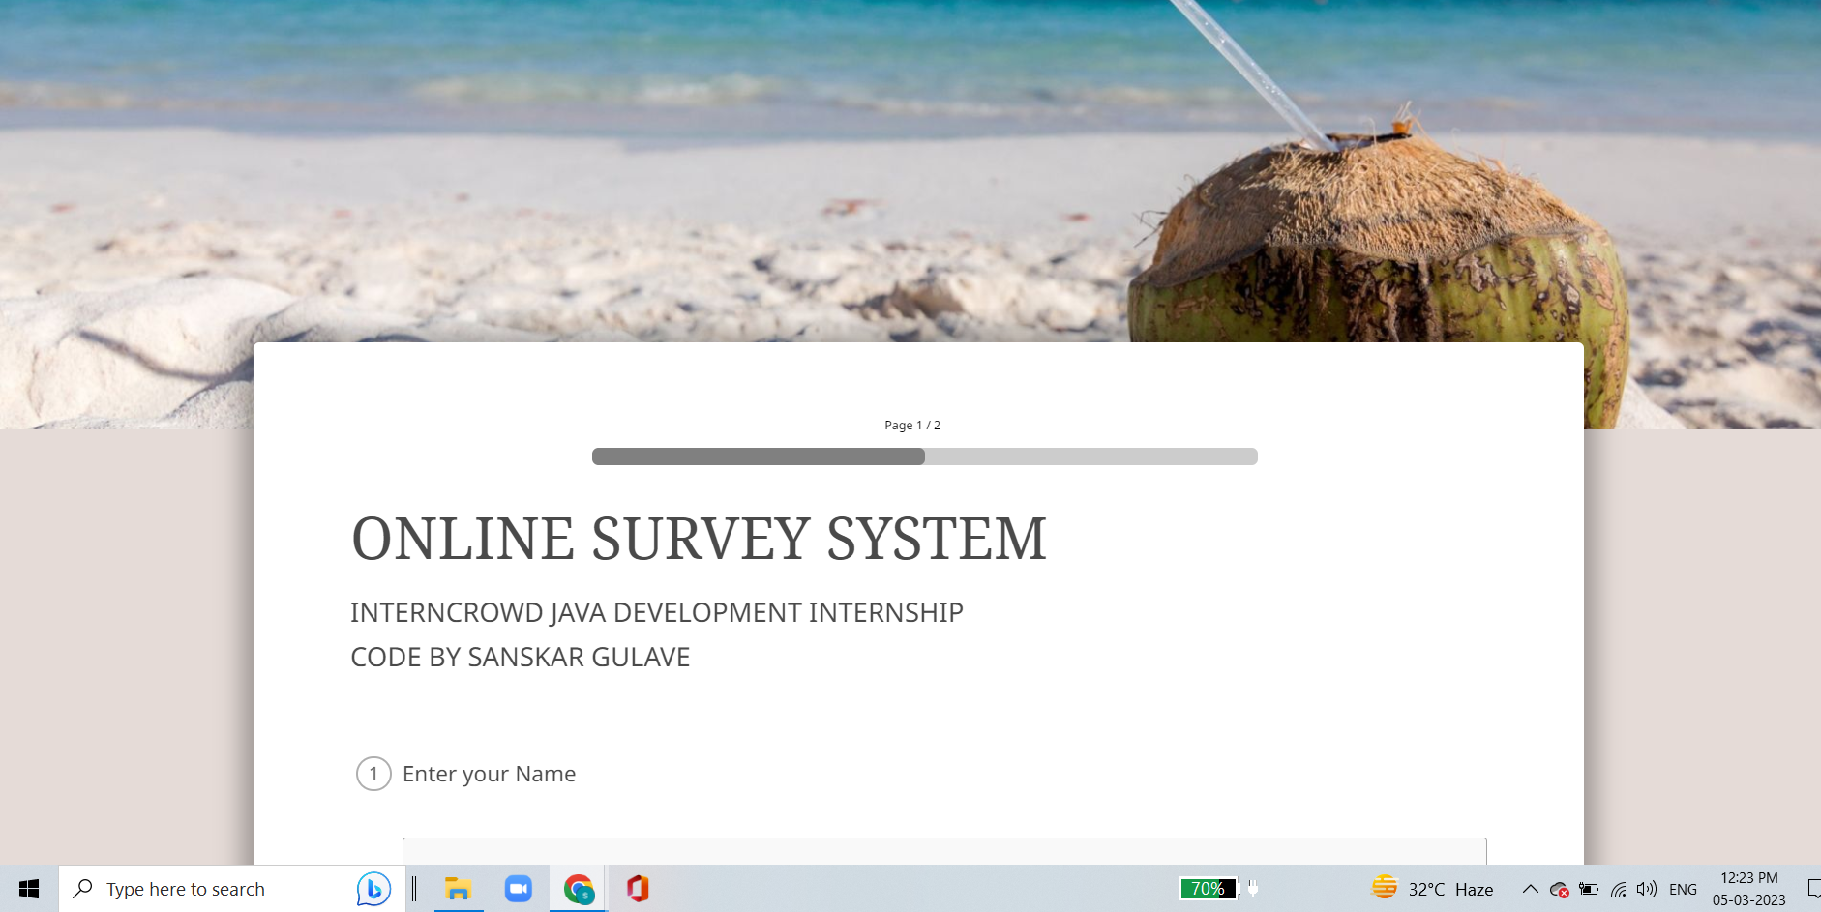

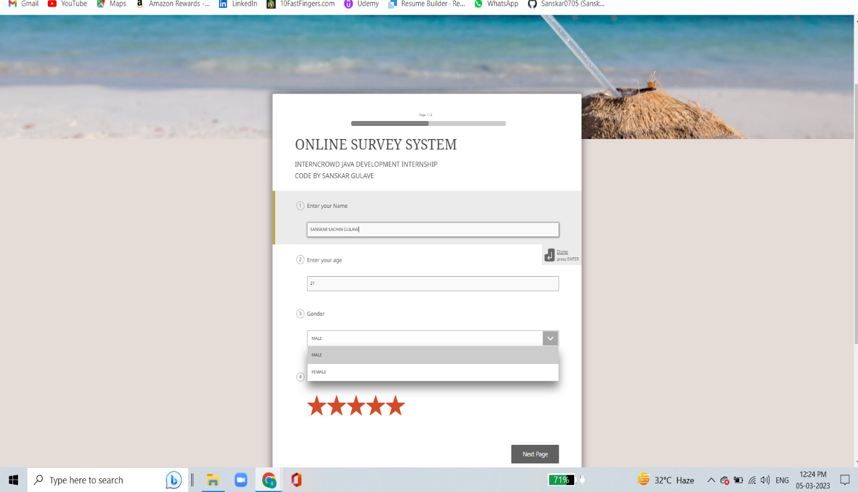

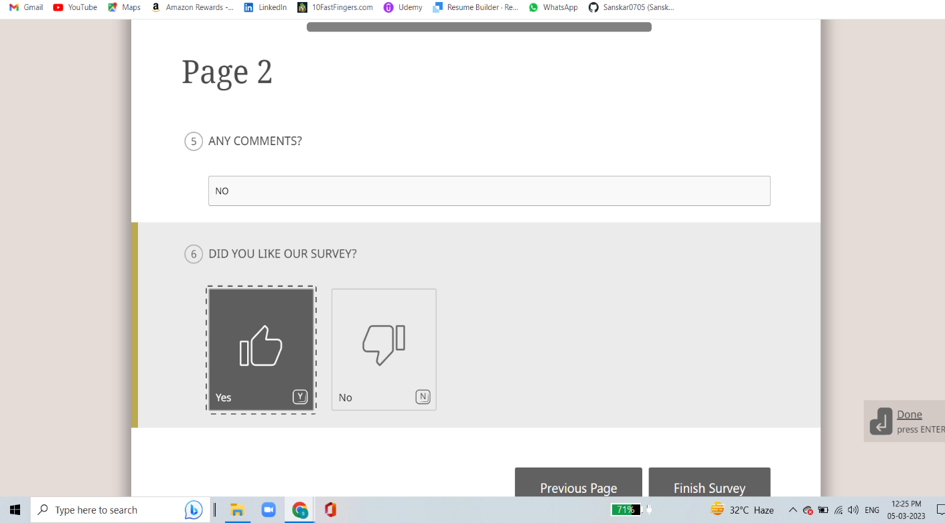

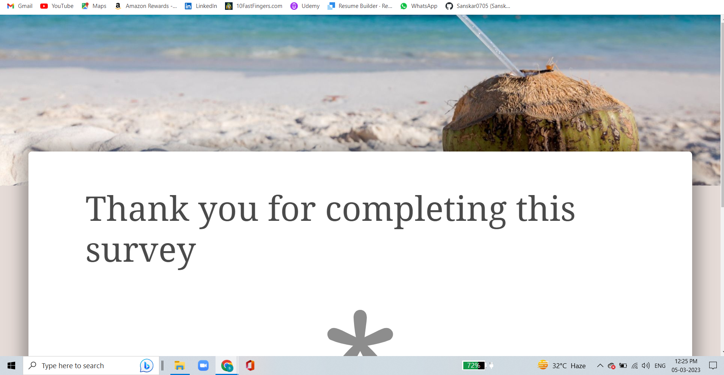

THANK

YOU !!!